Inner and Outer Joins

Queries
The Query by Example (QBE) interface lets us construct queries visually. Alternatively, we can switch to the SQL view. If you modify the SQL you may use a feature (such as SQL Union) and not be able to return to the Access Design View. However, the SQL view is useful to help learn the structure of the SQL Select statement.
In Design View, if we include more than one table and if we have previously established relationships between the tables, then access will create a join for us. In Design View we can always alter or include new relationships; the Relationships Tool diagram just establishes a default for any queries. All of the joins set up by Access are equi-joins, that is, the operator used to compare fields is the equals (“=”) operator. These are the most common way of joining two tables. The following diagram shows the Relationships Tool Diagram for an Invoice database:
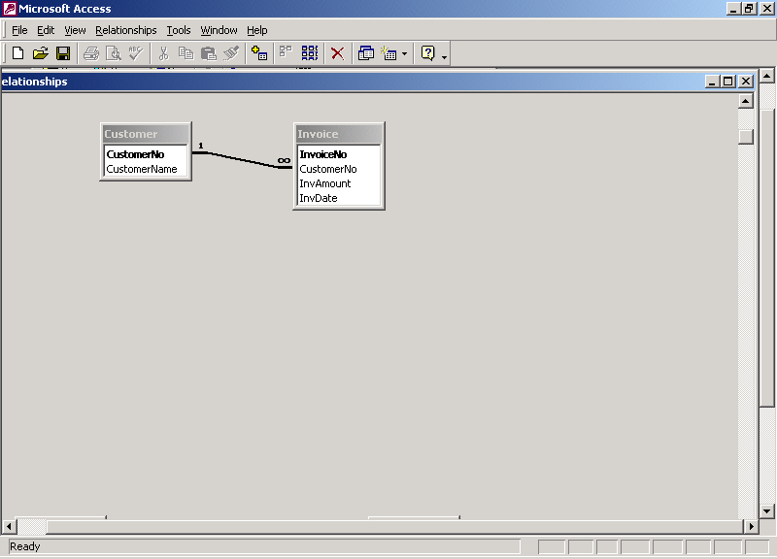

If you edit the relationship line (double-click it), you can begin to see the join properties:
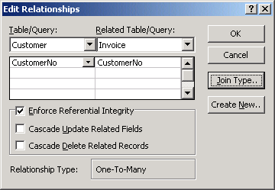
Here we can see the join is based on the common attribute CustomerNo. If you click on the Join Type button, you will get information on the type of join used. You will see (as the following diagram shows) that Access has selected the first of three options:
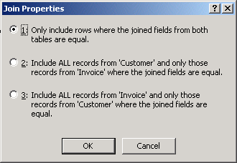
Joins can be characterized as inner or outer joins. By default, Access creates inner joins (Option 1 above).
Options 2 and 3 are outer joins. One of these would also be called a Left Outer Join and the other a Right Outer Join. If you examine the SQL statement generated you will see which is used; Left and Right choices are related to the textual expression of the SQL statement – which table name is leftmost/rightmost in the From clause. The concept of join type is a very important notion for relational databases. And the concept of outer join is very important; sometimes you will need an inner, and sometimes you will need an outer join.
Inner Join
For a record to be included in the result of an inner join, there must be a row for it to be joined to. For instance, suppose we join the Customer and Invoice tables using an inner join based on the CustomerNo.
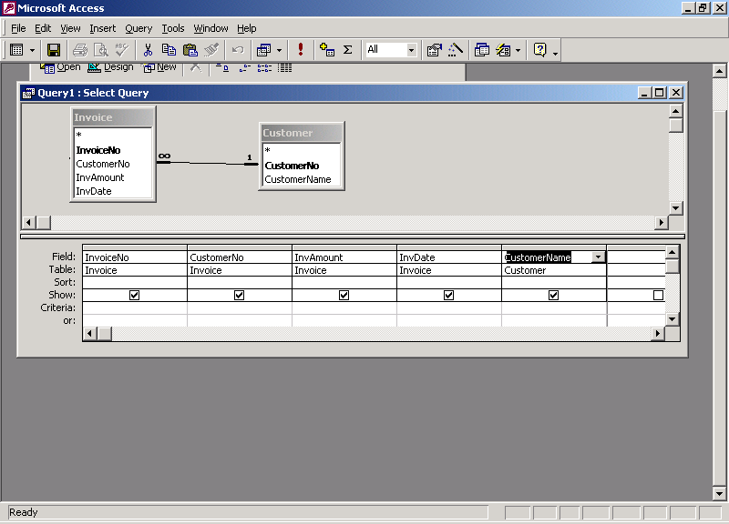
The query in Design View

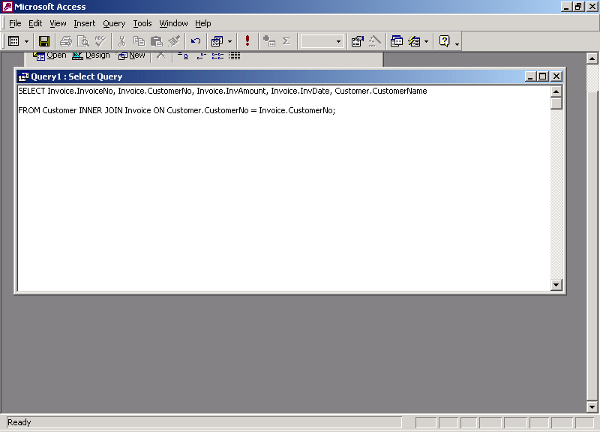
The query in SQL View

If the Invoice and Customer tables have the contents shown below,
Invoice table:
InvoiceNo | CustomerNo | InvAmount | InvDate
123 | 555 | 100.00 | Jan 1, 2002
222 | 444 | 250.00 | Jan 17, 2002
333 | 444 | 175.00 | Jan 18, 2002
Customer table:
CustomerNo | CustomerName
444 | Jim Smith
500 | Steven Stevens
555 | Peter Parker
then the result of running the query is
InvoiceNo | CustomerNo | InvAmount | InvDate | CustomerName
123 | 555 | 100.00 | Jan 1, 2002 | Peter Parker
222 | 444 | 250.00 | Jan 17, 2002 | Jim Smith
333 | 444 | 175.00 | Jan 18, 2002 | Jim Smith
In the above result notice there is no line for Steven Stevens; this is because there was no row in Invoice that had a value of 500 for CustomerNo. This query demonstrates a distinguishing characteristic of the inner join: only rows in the one table that match rows in the other table are included in the results.
Outer Join
Now, suppose we wanted to produce a report that lists each customer and the total amount they have been invoiced. We would want all customers to appear in the report, even Steven Stevens.
When you create a report in Access, you need a query to provide the data to be displayed in that report. In this case we need to use an Outer Join query, the one we could get by choosing Option 2 for the join type.
Note what option 2 emphasizes: “Include ALL records from Customer …”. If we choose Option 2, then our query would give us the following result:
InvoiceNo | CustomerNo | InvAmount | InvDate | CustomerName
123 | 555 | 100.00 | Jan 1, 2002 | Peter Parker
222 | 444 | 250.00 | Jan 17, 2002 | Jim Smith
333 | 444 | 175.00 | Jan 18, 2002 | Jim Smith
Null | 500 | Null | Null | Steven Stevens
A really important thing to note here is that we have a row for Steven Stevens. We would say here, that the row for customer 500 was joined to a row of nulls (the InvoiceNo is null, the InvAmount is null, the InvDate is null).
This type of result is very useful to us. For instance, we could now modify our query so that it is a Totals query where we group by CustomerNo (and CustomerName) and include a count of the number of invoices and a total for invoice amount. In Design View, the query would look like:
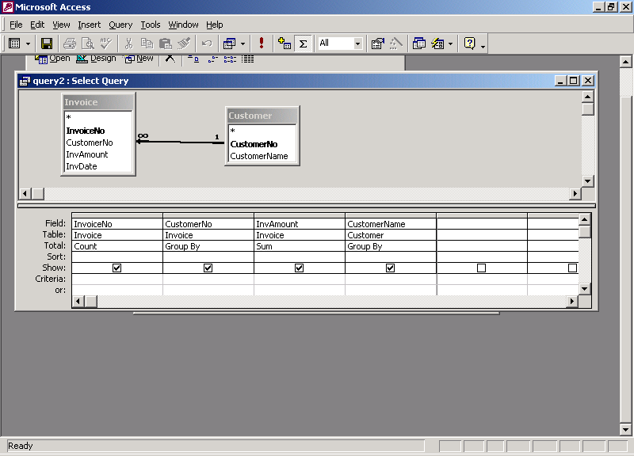
And the result produced is:
Number of Invoices | CustomerNo | Total of Invoices | CustomerName
123 | 555 | $100.00 | Peter Parker
222 | 444 | $425.00 | Jim Smith
0 | 500 | $0 | Steven Stevens
When you examine the outer join query in the Design View above, you should notice one small visual detail: the relationships line is now a directed line (there’s an arrow head at the Invoice table).

SQL Select Statement
SQL is the standard language for relational database systems. There are other variations of SQL that appear in Object-oriented database systems, and elsewhere. So, the study of SQL is very important and the knowledge gained is transferable to other database environments.
The general SQL Select statement syntax:
Select list of attributes or calculated results ⁽¹⁾
From list of tables with/without join condition ⁽²⁾
Where criteria row(s) must meet beyond the join specifications ⁽³⁾
Group by list of attributes for creating groups ⁽⁴⁾
Order by list of attributes for ordering the results ⁽⁵⁾
Each clause of the SQL statement has its counterpart in the Design View used by Access:
(1) The attribute/calculated values are specified in the Field row in Design View; If grouping is used, these must yield a single value (group functions; grouping attribute) for the group.
(2) The tables that appear in the From clause are shown in the Table row & in the Relationships of Design View. If it’s a simple On condition, it is an inner join; if is specifies Left Join or Right Join, then the query is an outer join (left or right)
(3) The specification for the Where clause are found in the Criteria and Or rows of Design View.
(4) The specification for grouping is made by using the Totals button and the Totals row of the Design View.
(5) The specifications for sorting the final result is made in the Sort

